**The Healing Harvest**

**Dedicating Abundant Resources and Support—The Gold Alliance**



**H.N. and Frances C. Berger Foundation**

**and**

[**KESQ News Channel 3**](http://www.kesq.com)

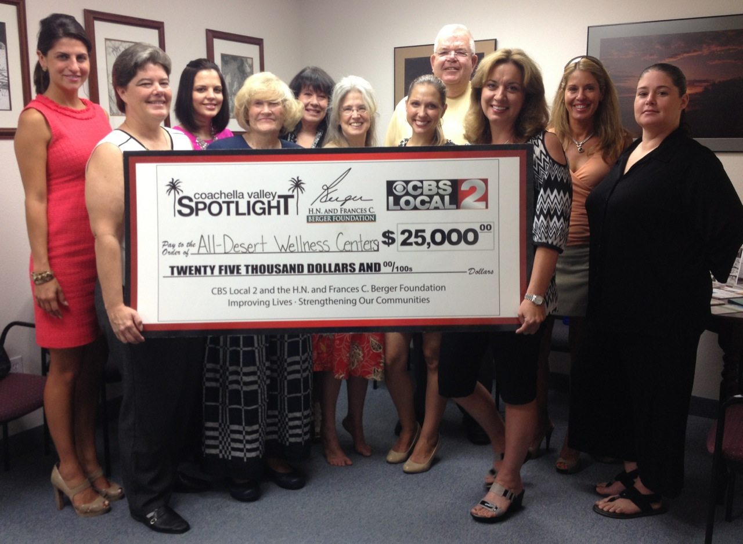

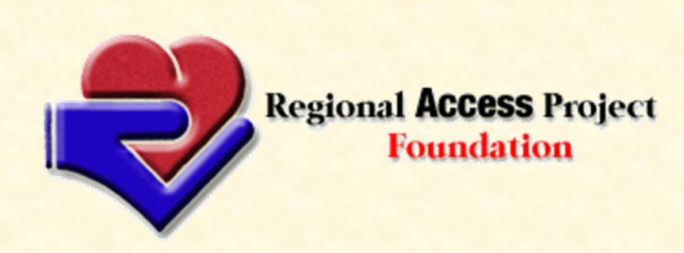[**Lani D. Long, LMFT**](http://www.deepcanyoncounseling.com/Lani.html)

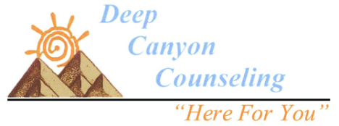

**Catherine Eklund-Mares** [**RAP Foundation**](http://www.regionalaccessproject.org/)

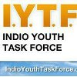

**Pacific Road U.S.A.**



[**The Coachella Valley**](http://cvcommunitytrust.org/)

[**Community Trust**](http://cvcommunitytrust.org/)

[**Sharron Zarres, LMFT**](https://sharonzarrescounseling.com/)

[**Toyota 100 Cars For Good**](https://apps.facebook.com/carsforgood/)