

173d Peace Chapel

&

OTANY Resort

The United States faces a growing problem. Our military service personnel are coping with physical and emotional stresses that prevent them from performing to their optimum potential. There is little infrastructure to support them whether they are on active duty or rotating back into civilian life. The Psychiatric Times reports a 'gathering storm' due to the estimated 70 percent of our soldiers and veterans who will not seek help from federal agencies.

**All-Desert Wellness Centers is working in conjunction with**

**173d Peace Chapel & OTANY Resort**

**to heal our veterans & their families**

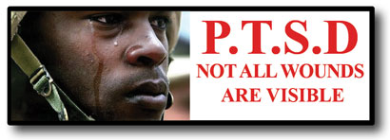

**They give everything for our nation.**

**What will you give for them?  
What would you pay to ensure that our**

**military stays healthy enough to protect**

**our country and ensure our freedom?  
Please help us keep our military strong.**

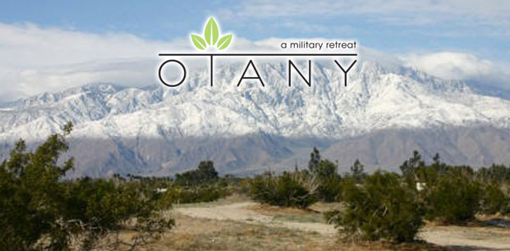

Peace Chapel will be surrounded by OTANY, an eco resort and retreat program for our military and veterans. OTANY is a name we coined meaning "Opening To A New You." Our project has been especially designed to help our service members and those in need.

Visit [www.173dpeacechapel.com](http://www.173dpeacechapel.com) for more information